**CPM – Critical Path Method**

|  |  |  |  |
| --- | --- | --- | --- |
| **Name** | **Task** | **Predecessor** | **Duration** |
| A | Requirement Meetings |  | 5 days |
| B | Cost & Benefit Analysis | A | 7 days |
| C | Risk Analysis | A,B | 2 days |
| D | Use Case Diagram | A | 10 days |
| E | Data Model | D | 6 days |
| F | Prototype | D | 30 days |
| G | Front-End Development | F | 32 days |
| H | Back-End Development | G | 52 days |
| I | Testing | H,G | 47 days |
| J | Deployment | H,I | 6 days |

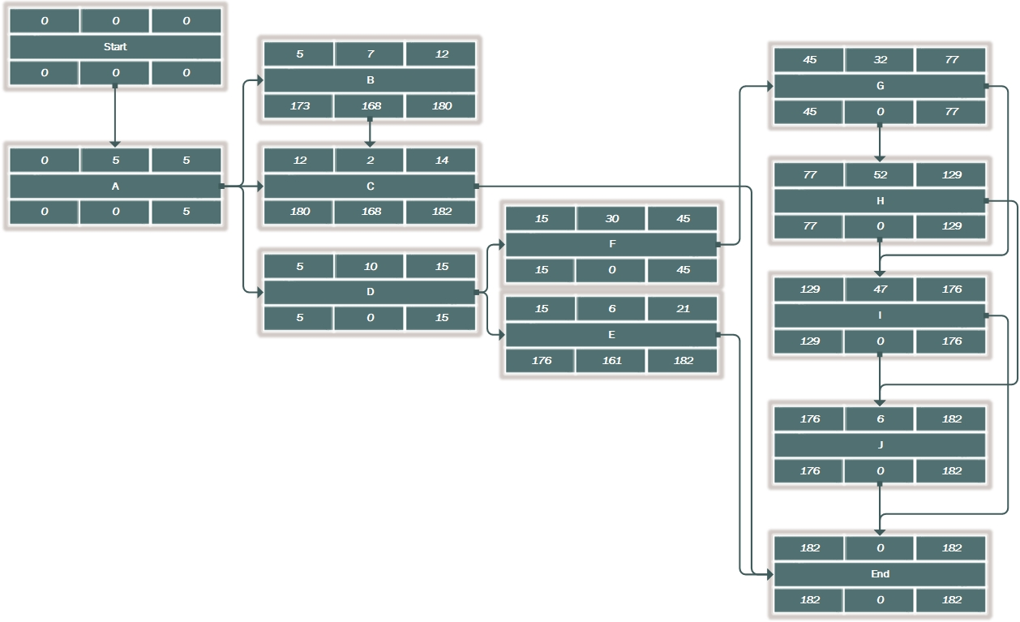

|  |  |  |  |  |  |
| --- | --- | --- | --- | --- | --- |
| **Name** | **ES** | **EF** | **LS** | **LF** | **Lag** |
| Start | 0 | 0 | 0 | 0 | 0 |
| A | 0 | 5 | 0 | 5 | 0 |
| B | 5 | 12 | 173 | 180 | 168 |
| C | 12 | 14 | 180 | 182 | 168 |
| D | 5 | 15 | 5 | 15 | 0 |
| E | 15 | 21 | 176 | 182 | 161 |
| F | 15 | 45 | 15 | 45 | 0 |
| G | 45 | 77 | 45 | 77 | 0 |
| H | 77 | 129 | 77 | 129 | 0 |
| I | 129 | 176 | 129 | 176 | 0 |
| J | 176 | 182 | 176 | 182 | 0 |
| End | 182 | 182 | 182 | 182 | 0 |

**Critical Paths:**

**Start -> A -> D -> F -> G -> H -> I -> J -> End**

